UNIT-5
DISTANCE MEASURES:
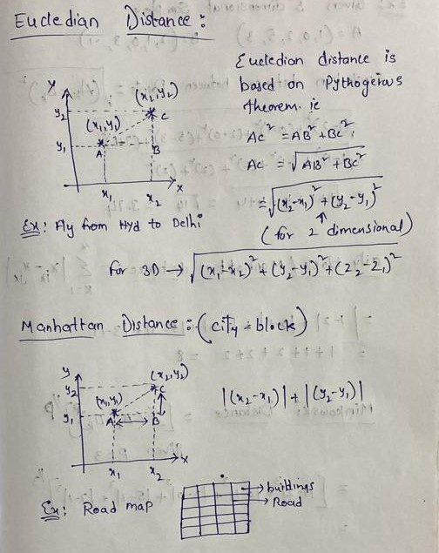
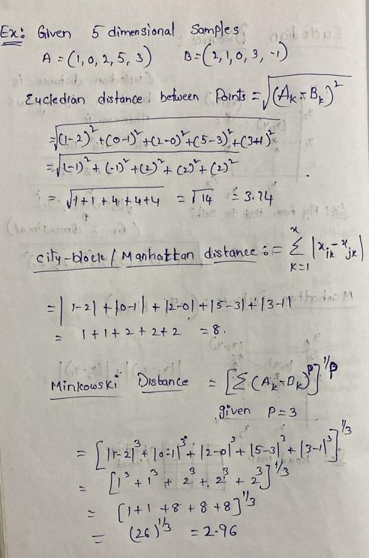
Minkowski distance is primarily used in machine learning and data science, particularly in algorithms that require measuring the similarity or dissimilarity between data points, like K-Nearest Neighbors (KNN), clustering algorithms (e.g., K-Means), and other classification tasks

K-Nearest Neighbor(KNN) Algorithm for Machine Learning
- K-Nearest Neighbour is one of the simplest Machine Learning algorithms based on Supervised Learning technique.
- K-NN algorithm assumes the similarity between the new case/data and available cases and put the new case into the category that is most similar to the available categories.
- K-NN algorithm stores all the available data and classifies a new data point based on the similarity. This means when new data appears then it can be easily classified into a well suite category by using K- NN algorithm.
- K-NN algorithm can be used for Regression as well as for Classification but mostly it is used for the Classification problems.
- It is also called a lazy learner algorithm because it does not learn from the training set immediately instead it stores the dataset and at the time of classification, it performs an action on the dataset.
- KNN algorithm at the training phase just stores the dataset and when it gets new data, then it classifies that data into a category that is much similar to the new data.
- Example: Suppose, we have an image of a creature that looks similar to cat and dog, but we want to know either it is a cat or dog. So for this identification, we can use the KNN algorithm, as it works on a similarity measure. Our KNN model will find the similar features of the new data set to the cats and dogs images and based on the most similar features it will put it in either cat or dog category.

Why do we need a K-NN Algorithm?
Suppose there are two categories, i.e., Category A and Category B, and we have a new data point x1, so this data point will lie in which of these categories. To solve this type of problem, we need a K-NN algorithm. With the help of K-NN, we can easily identify the category or class of a particular dataset. Consider the below diagram:
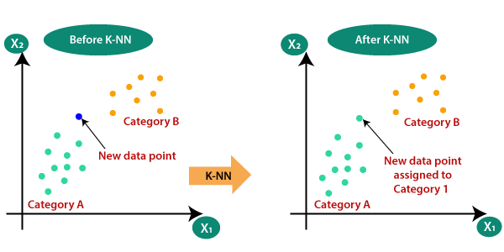

How does K-NN work?
The K-NN working can be explained on the basis of the below algorithm:
- Step-1: Select the number K of the neighbors
- Step-2: Calculate the Euclidean distance of K number of neighbors
- Step-3: Take the K nearest neighbors as per the calculated Euclidean distance.
- Step-4: Among these k neighbors, count the number of the data points in each category.
- Step-5: Assign the new data points to that category for which the number of the neighbor is maximum.
- Step-6: Our model is ready.
- Firstly, we will choose the number of neighbors, so we will choose the k=5.
- Next, we will calculate the Euclidean distance between the data points. The Euclidean distance is the distance between two points, which we have already studied in geometry. It can be calculated as:
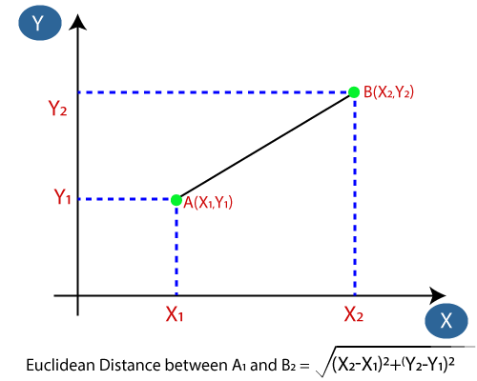
- By calculating the Euclidean distance we got the nearest neighbors, as three nearest neighbors in category A and two nearest neighbors in category B. Consider the below image:
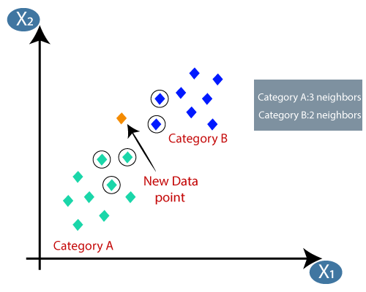
- As we can see the 3 nearest neighbors are from category A, hence this new data point must belong to category A.

How to select the value of K in the K-NN Algorithm?
- There is no particular way to determine the best value for "K", so we need to try some values to find the best out of them. The most preferred value for K is 5.
- A very low value for K such as K=1 or K=2, can be noisy and lead to the effects of outliers in the model.
- Large values for K are good, but it may find some difficulties.

Advantages of KNN Algorithm:
- It is simple to implement.
- It is robust to the noisy training data
- It can be more effective if the training data is large.

Disadvantages of KNN Algorithm:
- Always needs to determine the value of K which may be complex some time.
- The computation cost is high because of calculating the distance between the data points for all the training samples.

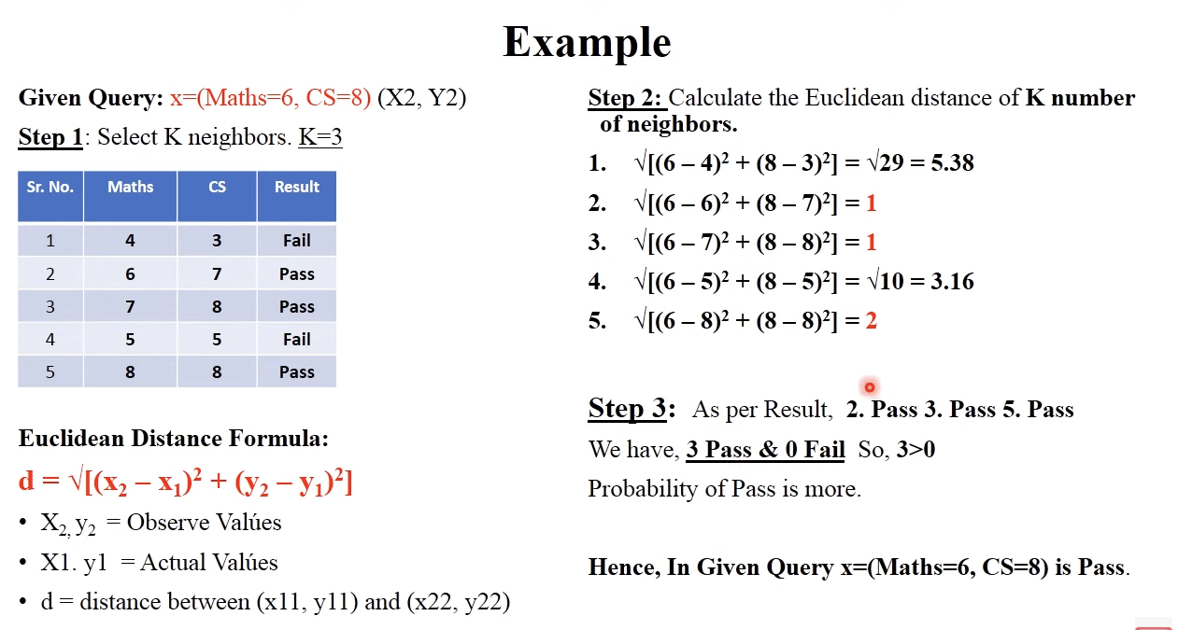

DISTANCE BASED CLUSTURING:
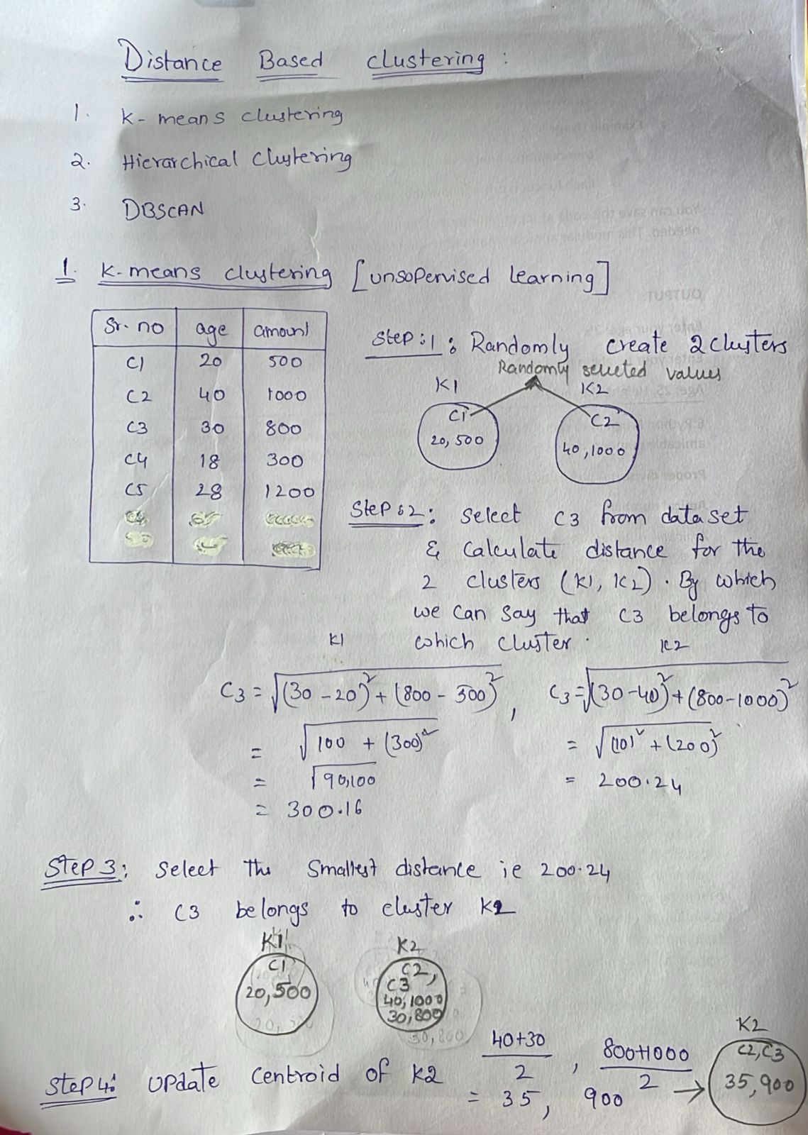
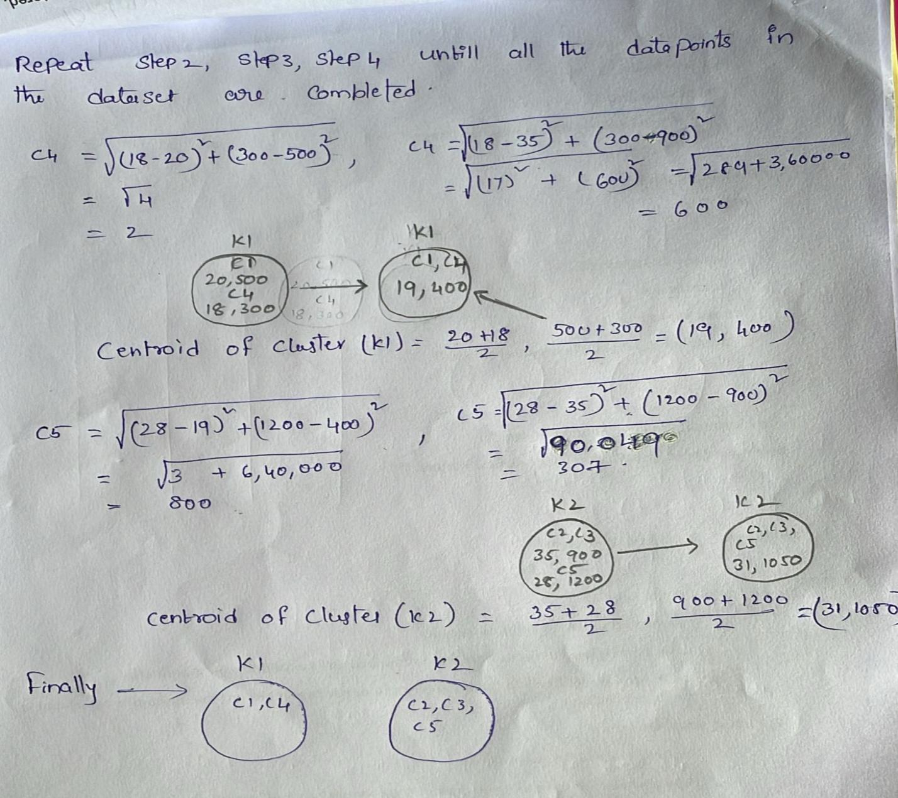
Hierarchical clustering is another unsupervised machine learning algorithm, which is used to group the unlabeled datasets into a cluster and also known as hierarchical cluster analysis or HCA.
In this algorithm, we develop the hierarchy of clusters in the form of a tree, and this tree-shaped structure is known as the dendrogram.
Sometimes the results of K-means clustering and hierarchical clustering may look similar, but they both differ depending on how they work. As there is no requirement to predetermine the number of clusters as we did in the K-Means algorithm.
The hierarchical clustering technique has two approaches:
Agglomerative: Agglomerative is a bottom-up approach, in which the algorithm starts with taking all data points as single clusters and merging them until one cluster is left.
Divisive: Divisive algorithm is the reverse of the agglomerative algorithm as it is a top-down approach.
Why hierarchical clustering?
As we already have other clustering algorithms such as K-Means Clustering, then why we need hierarchical clustering? So, as we have seen in the K-means clustering that there are some challenges with this algorithm, which are a predetermined number of clusters, and it always tries to create the clusters of the same size. To solve these two challenges, we can opt for the hierarchical clustering algorithm because, in this algorithm, we don't need to have knowledge about the predefined number of clusters.
Agglomerative Hierarchical clustering
The agglomerative hierarchical clustering algorithm is a popular example of HCA. To group the datasets into clusters, it follows the bottom-up approach. It means, this algorithm considers each dataset as a single cluster at the beginning, and then start combining the closest pair of clusters together. It does this until all the clusters are merged into a single cluster that contains all the datasets.
This hierarchy of clusters is represented in the form of the dendrogram.
How the Agglomerative Hierarchical clustering Work?
The working of the AHC algorithm can be explained using the below steps:
Step-1: Create each data point as a single cluster. Let's say there are N data points, so the number of clusters will also be N.
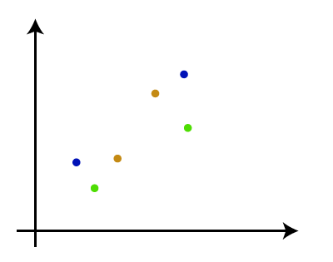
Step-2: Take two closest data points or clusters and merge them to form one cluster. So, there will now be N-1 clusters.
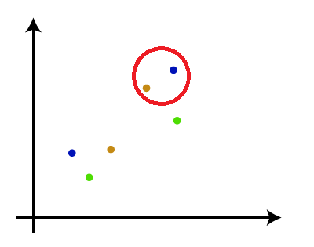
Step-3: Again, take the two closest clusters and merge them together to form one cluster. There will be N-2 clusters.
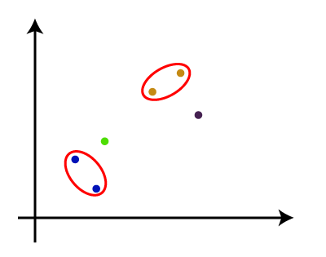
Step-4: Repeat Step 3 until only one cluster left. So, we will get the following clusters. Consider the below images:
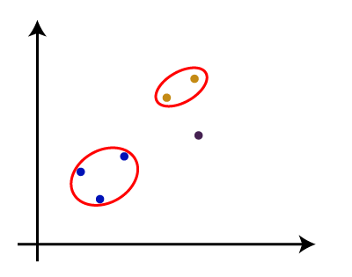
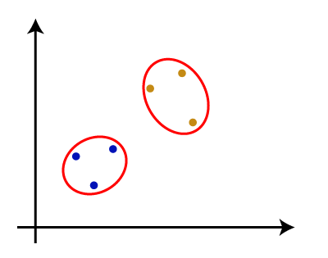
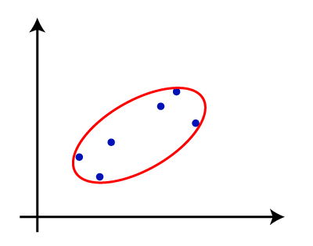
Step-5: Once all the clusters are combined into one big cluster, develop the dendrogram to divide the clusters as per the problem.
Measure for the distance between two clusters
As we have seen, the closest distance between the two clusters is crucial for the hierarchical clustering. There are various ways to calculate the distance between two clusters, and these ways decide the rule for clustering. These measures are called Linkage methods. Some of the popular linkage methods are given below:
Single Linkage: It is the Shortest Distance between the closest points of the clusters. Consider the below image:
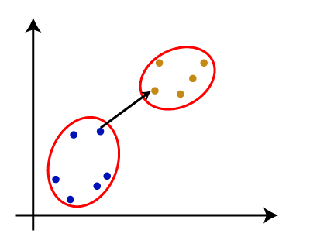
Complete Linkage: It is the farthest distance between the two points of two different clusters. It is one of the popular linkage methods as it forms tighter clusters than single-linkage.
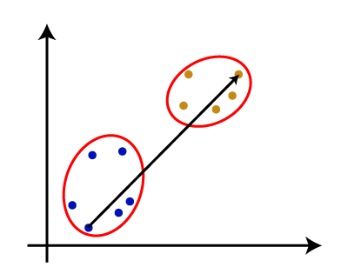
Average Linkage: It is the linkage method in which the distance between each pair of datasets is added up and then divided by the total number of datasets to calculate the average distance between two clusters. It is also one of the most popular linkage methods.
Centroid Linkage: It is the linkage method in which the distance between the centroid of the clusters is calculated. Consider the below image:
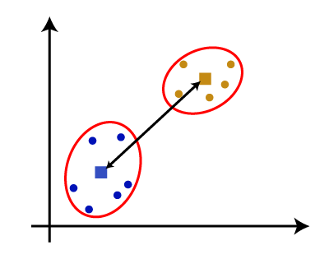
From the above-given approaches, we can apply any of them according to the type of problem or business requirement.

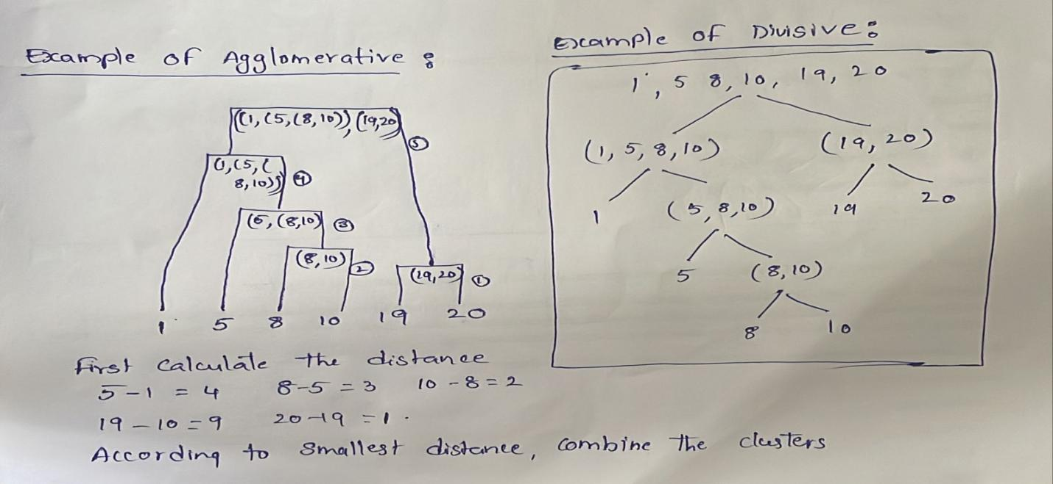

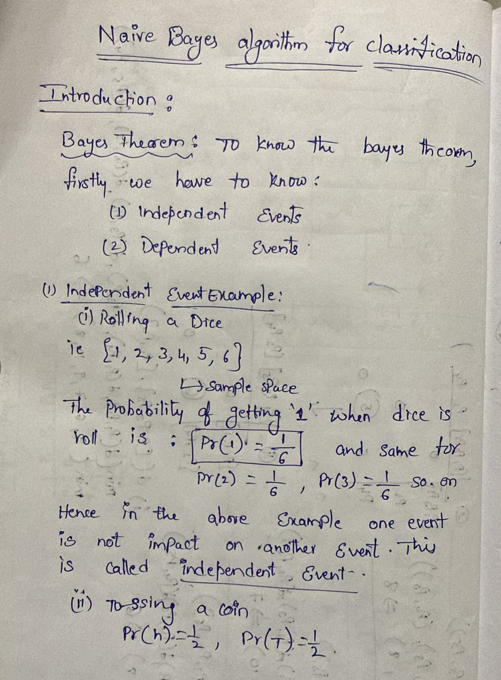
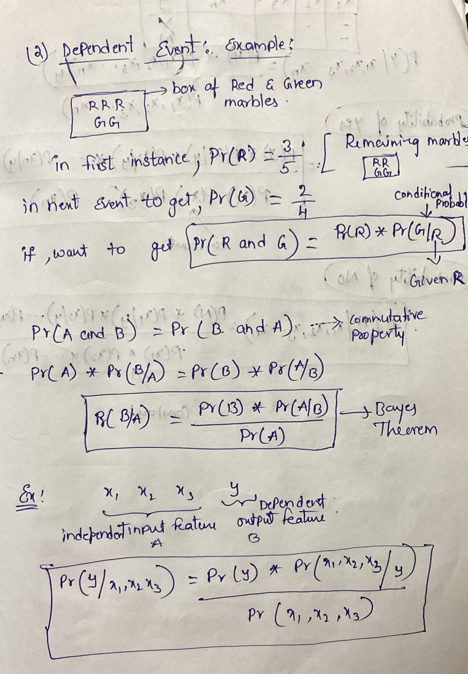
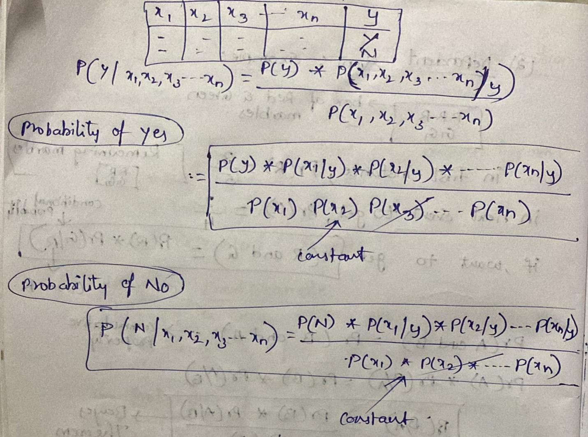

EXAMPLE:
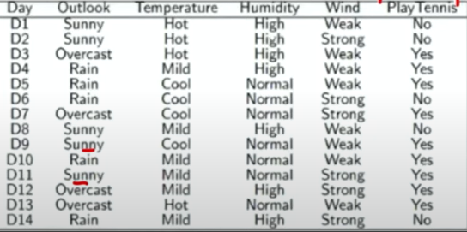
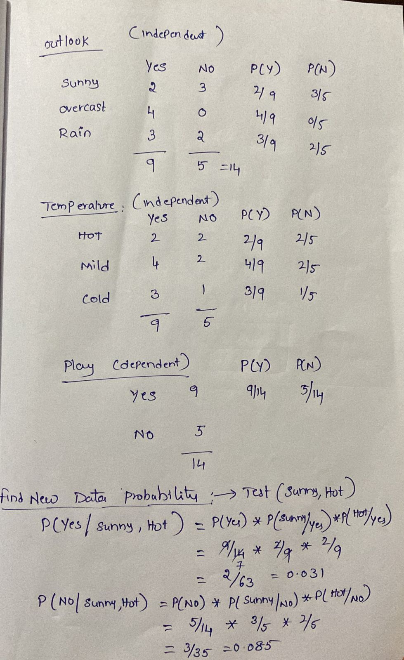

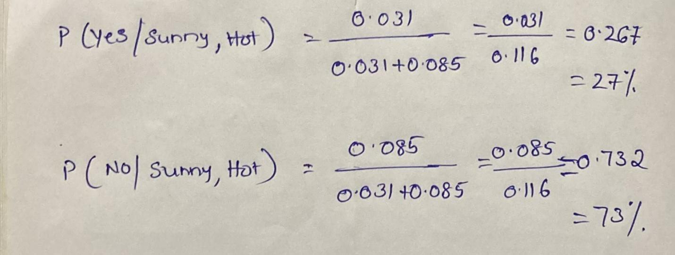
From the above calculation :
p(yes/sunny,hot) < p(No/sunny,hot)
27 < 73
Hence we can conclude ‘not to play’ as the probability of NO is 73%

Laplace Smoothing
From the dataset, the occurrences of "Overcast" under Play Tennis:
Outlook | Play Tennis | Count
Overcast | Yes | 4
Overcast | No | 0
Total occurrences of "Overcast" = 4 (Yes) + 0 (No) = 4

Step 2: Calculate Probability Without Smoothing
Without smoothing, the probability of Play Tennis being "No" when Outlook is "Overcast" is:
P(Yes/Overcast)=4/9

P(No∣Overcast)= 0/5=0
This is problematic because a zero probability would completely eliminate this case from any classification calculations.

Step 3: Apply Laplace Smoothing
Using Laplace Smoothing (k = 1), we add 1 to all category counts. The formula is:
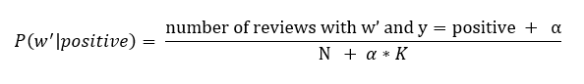
α = Smoothing parameter (typically 1, but can be any positive number)
K=total no of classes
N=Total number of w’ in class
Since we have two possible classes (Yes and No), we add 2 in the denominator:
Similarly, for "Yes":
P(Yes/Overcast)=4+1/9+2=5/11=0.45=45%
P(No∣Overcast)= 0+1/5+2=1/7=0.14=14%
Why is Laplace Smoothing Important?
- Without smoothing, P(No∣Overcast)=0 means we would never predict "No" if Outlook is Overcast.
- With smoothing, we allow a small probability 14% for "No", preventing a total elimination of this case in classification.
- This helps avoid overfilling to a small data set and ensures better generalization.

ENSEMBLING METHODS:
To improve the accuracy (estimate) of the model, ensemble learning methods are developed. Ensemble is a machine learning concept, in which several models are trained using machine learning algorithms. It combines low performing classifiers (also called as weak learners or base learner) and combine individual model prediction for the final prediction.
On the basis of type of base learners, ensemble methods can be categorized as homogeneous and heterogeneous ensemble methods. If base learners are same, then it is a homogeneous ensemble method. If base learners are different then it is a heterogeneous ensemble method.

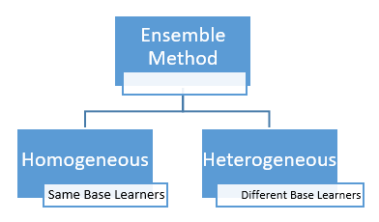

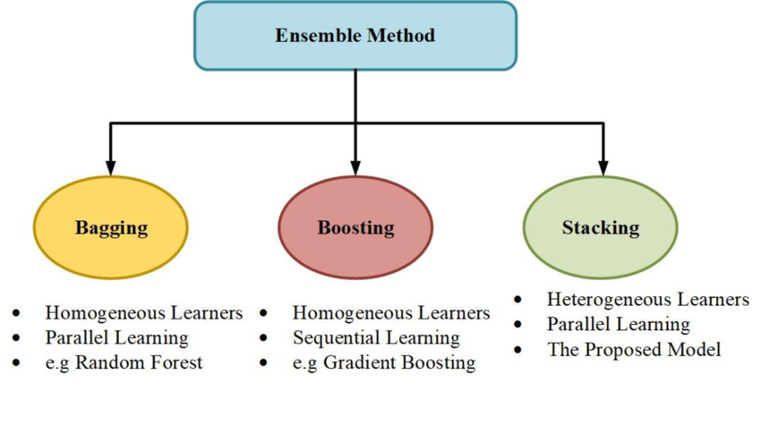

Bagging

Consider a scenario where you are looking at the users’ ratings for a product. Instead of approving one user’s good/bad rating, we consider average rating given to the product. With average rating, we can be considerably sure of quality of the product. Bagging makes use of this principle. Instead of depending on one model, it runs the data through multiple models in parallel, and average them out as model’s final output.
What is Bagging? How it works?
- Bagging is an acronym for Bootstrapped Aggregation. Bootstrapping means random selection of records with replacement from the training dataset. ‘Random selection with replacement’ can be explained as follows:
- Consider that there are 8 samples in the training dataset. Out of these 8 samples, every weak learner gets 5 samples as training data for the model. These 5 samples need not be unique, or non-repetitive.
- The model (weak learner) is allowed to get a sample multiple times. For example, as shown in the figure, Rec5 is selected 2 times by the model. Therefore, weak learner1 gets Rec2, Rec5, Rec8, Rec5, Rec4 as training data.
- All the samples are available for selection to next weak learners. Thus all 8 samples will be available for next weak learner and any sample can be selected multiple times by next weak learners.
- Bagging is a parallel method, which means several weak learners learn the data pattern independently and simultaneously. This can be best shown in the below diagram:
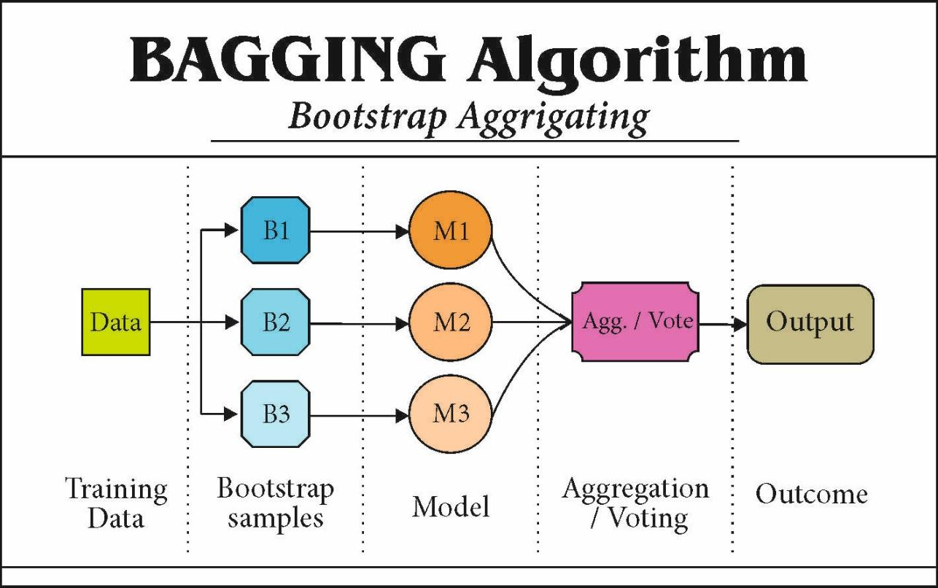
- The output of each weak learner is averaged to

- generate final output of the model.
- Since the weak learner’s outputs are averaged, this mechanism helps to reduce variance or variability in the predictions. However, it does not help to reduce bias of the model.
- Since final prediction is an average of output of each weak learner, it means that each weak learner has equal weight in the final output.

Random Forest Algorithm
Random Forest is a popular machine learning algorithm that belongs to the supervised learning technique. It can be used for both Classification and Regression problems in ML. It is based on the concept of ensemble learning, which is a process of combining multiple classifiers to solve a complex problem and to improve the performance of the model.
As the name suggests, "Random Forest is a classifier that contains a number of decision trees on various subsets of the given dataset and takes the average to improve the predictive accuracy of that dataset." Instead of relying on one decision tree, the random forest takes the prediction from each tree and based on the majority votes of predictions, and it predicts the final output.
The greater number of trees in the forest leads to higher accuracy and prevents the problem of overfitting.
The below diagram explains the working of the Random Forest algorithm:
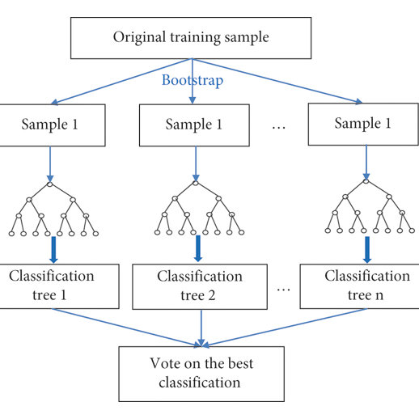
How does Random Forest algorithm work?
Random Forest works in two-phase first is to create the random forest by combining N decision tree, and second is to make predictions for each tree created in the first phase.
The Working process can be explained in the below steps and diagram:
Step-1: Select random K data points from the training set.
Step-2: Build the decision trees associated with the selected data points (Subsets).
Step-3: Choose the number N for decision trees that you want to build.
Step-4: Repeat Step 1 & 2.
Step-5: For new data points, find the predictions of each decision tree, and assign the new data points to the category that wins the majority votes.
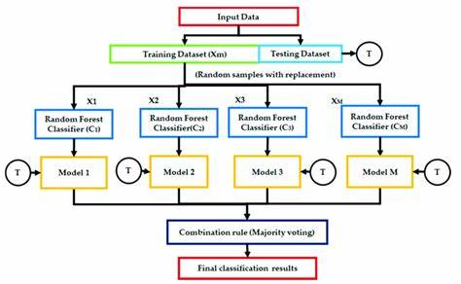

Applications of Random Forest
There are mainly four sectors where Random forest mostly used:
- Banking: Banking sector mostly uses this algorithm for the identification of loan risk.
- Medicine: With the help of this algorithm, disease trends and risks of the disease can be identified.
- Land Use: We can identify the areas of similar land use by this algorithm.
- Marketing: Marketing trends can be identified using this algorithm.
Advantages of Random Forest
- Random Forest is capable of performing both Classification and Regression tasks.
- It is capable of handling large datasets with high dimensionality.
- It enhances the accuracy of the model and prevents the overfitting issue.
Disadvantages of Random Forest
- Although random forest can be used for both classification and regression tasks, it is not more suitable for Regression tasks.
What is Boosting?
Definition: The term ‘Boosting’ refers to a family of algorithms which converts weak learner to strong learners.
Let’s understand this definition in detail by solving a problem of spam email identification:
How would you classify an email as SPAM or not? Like everyone else, our initial approach would be to identify ‘spam’ and ‘not spam’ emails using following criteria. If:
- Email has only one image file (promotional image), It’s a SPAM
- Email has only link(s), It’s a SPAM
- Email body consist of sentence like “You won a prize money of $ xxxxxx”, It’s a SPAM
- Email from our official domain “nri@nriit.edu.in” , Not a SPAM
- Email from known source, Not a SPAM
Above, we’ve defined multiple rules to classify an email into ‘spam’ or ‘not spam’. But, do you think these rules individually are strong enough to successfully classify an email? No.
Individually, these rules are not powerful enough to classify an email into ‘spam’ or ‘not spam’. Therefore, these rules are called as weak learner.
To convert weak learner to strong learner, we’ll combine the prediction of each weak learner using methods like:
• Using average/ weighted average
• Considering prediction has higher vote
For example: Above, we have defined 5 weak learners. Out of these 5, 3 are voted as ‘SPAM’ and 2 are voted as ‘Not a SPAM’. In this case, by default, we’ll consider an email as SPAM because we have higher(3) vote for ‘SPAM’.

How Boosting Algorithms works?
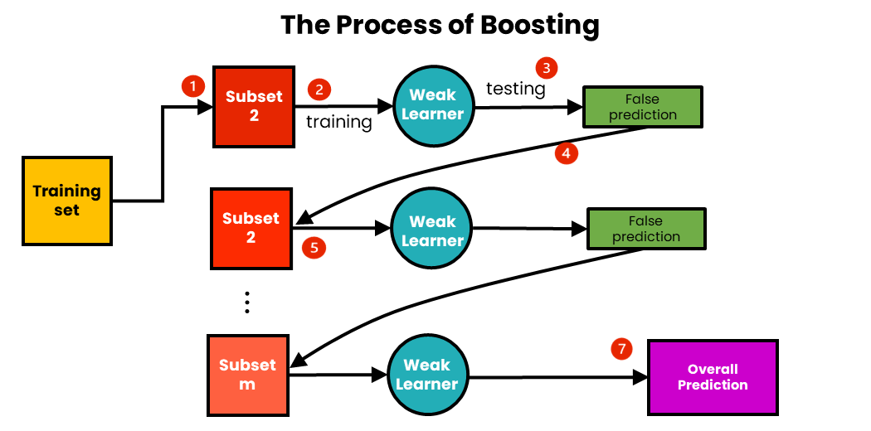

Now we know that, boosting combines weak learner to form a strong rule. An immediate question which should pop in your mind is, ‘How boosting identify weak rules?‘
To find weak rule, we apply base learning (ML) algorithms with a different distribution. Each time base learning algorithm is applied, it generates a new weak prediction rule. This is an iterative process. After many iterations, the boosting algorithm combines these weak rules into a single strong prediction rule.
Here’s another question which might haunt you, ‘How do we choose different distribution for each round?’
For choosing the right distribution, here are the following steps:
Step 1: The base learner takes all the distributions and assign equal weight or attention to each observation.
Step 2: If there is any prediction error caused by first base learning algorithm, then we pay higher attention to observations having prediction error. Then, we apply the next base learning algorithm.
Step 3: Iterate Step 2 till the limit of base learning algorithm is reached or higher accuracy is achieved.
Finally, it combines the outputs from weak learner and creates a strong learner which eventually improves the prediction power of the model. Boosting pays higher focus on examples which are mis-classiﬁed or have higher errors by preceding weak rules.

Types of Boosting Algorithms
Underlying engine used for boosting algorithms can be anything. It can be decision stamp, margin-maximizing classification algorithm etc. There are many boosting algorithms which use other types of engine such as:
- AdaBoost (Adaptive Boosting)
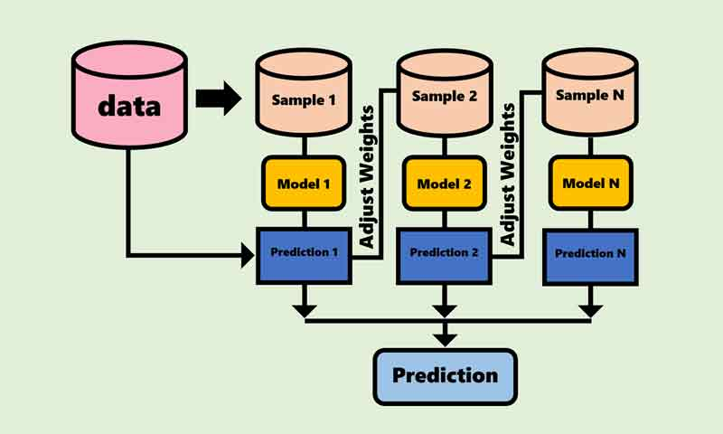
- Gradient Tree Boosting

